UIDAI Data Hackathon 2026

ANALYSIS OF AADHAAR ENROLLMENT

AND UPDATE TRENDS IN INDIA

INSIGHTS FOR DATA-DRIVEN DIGITA GOVERNANCE

Submitted to:
Unique Identification Authority of India (UIDAI)
Government of India
Through Data.gov.in Platform

Submitted by:
Sonal Chittode
Participant ID: UIDAI_9332
Email ID: sonalchittodeknw@gmail.com

Submission Date:


[19/01/2026]


TABLE OF CONTENTS

1. Introduction and Problem Statement .............................
2. Objectives of the Study ........................................
3. Dataset Description ............................................
3.1 Data Source .................................................
3.2 Key Variables Used ..........................................
4. Methodology ....................................................
4.1 Data Cleaning and Preprocessing .............................
4.2 Data Transformation and Aggregation .........................
4.3 Tools and Technologies ......................................
5. Data Analysis and Visualisation ................................
5.1 Enroll Data Analysis..............................
5.2 Biometric Data Analysis.............................
5.3 Demographic Data Analysis...................................
6. Key Insights and Findings ......................................
7. Impact and Applicability .......................................
8. Suggestions ...................................................
9.Conclusion ....................................................
INTRODUCTION AND PROBLEM STATEMENT
India’s Aadhaar programme is the world’s largest digital identity initiative, supporting millions of residents in accessing government services, welfare schemes, and digital infrastructure. With continuous enrollment and update activities across diverse geographic and demographic segments, Aadhaar generates large volumes of data that reflect citizen participation and system usage patterns. However, raw Aadhaar data by itself does not directly translate into actionable insights.There is a growing need to analyze this data systematically to identify trends, regional variations, and demographic patterns that can support evidence-based policymaking and efficient administrative planning.
The purpose of this report is to perform a comprehensive data analysis of Aadhaar enrollment, biometric updates, and demographic updates using UIDAI datasets. The analysis focuses on understanding how Aadhaar-related activities vary across states, districts, pincodes, age groups, and time periods.
The key objectives of this study are: - To analyze Aadhaar enrollment patterns across different regions and time periods - To examine biometric and demographic update trends across age groups - To identify under-served or high-activity regions requiring focused interventions - To simplify complex Aadhaar data using derived metrics such as total enrollment, total biometric updates, and total demographic updates - To present insights through clear and interpretable data visualisations

This analysis uses three UIDAI datasets—Enrollment, Biometric, and Demographic—each containing Date, State, District, Pincode, age-wise data categorized into 0–5 years, 5–17 years, and 17+ years. Derived total sum of enrolled , biometric and demographic were created by aggregating age groups to enable effective comparison and trend analysis across datasets.
The findings from this report are relevant for government stakeholders and policymakers as they support data-driven governance, targeted outreach planning, and monitoring of digital inclusion efforts. By translating large-scale Aadhaar data into meaningful insights, this report aims to contribute to improved decision-making and more efficient public service delivery.

OBJECTIVES
The objective of this study is to analyze Aadhaar-related data in order to derive meaningful insights that support informed decision-making and effective governance.
The specific objectives of the study are:
- To analyze overall Aadhaar-related activity across different regions
- To identify broad trends and variations over time
- To assess regional differences that may indicate uneven participation or service usage
- To present complex data in a simplified and interpretable manner through visual analysis
- To generate insights that can assist policymakers in monitoring andimproving Aadhaar-related initiatives.

DATASET DESCRIPTION
The analysis is based on Aadhaar-related datasets that capture enrollment activity, biometric updates, and demographic updates across different regions and time periods.
The datasets are structured at a granular geographic level and include age-wise information to enable detailed analysis.

Enrollment Dataset
This dataset provides aggregated information on Aadhaar enrolments across various demographic and geographic levels.
Key Fields:
- Date of Enrollment
- State
- District
- Pincode
- Age Group 0–5 years
- Age Group 5–17 years
- Age Group 18 years and above

Biometric Dataset
This dataset contains aggregated information on biometric updates (modalities such as fingerprints, iris, and face). It reflects the periodic revalidation or correction of biometric details, especially for children transitioning into adulthood.
Key Fields:
- Date of bimetic update
- State
- District
- Pincode
- Biometric Updates (Age 5–17 years)
- Biometric Updates (Age 17 years and above)

Demographic Dataset
This dataset captures aggregated information related to updates made to residents’ demographic data linked to Aadhaar, such as name, address, date of birth, gender, and mobile number. It provides insights into the frequency and distribution of demographic changes across different time periods and geographic levels
Key Fields:
- Date of updation
- State
- District
- Pincode
- Demographic Updates (Age 5–17 years)
- Demographic Updates (Age 17 years and above)

Derived Metrics
To support effective analysis and visualization, age-wise values were aggregated within each dataset to create total activity measures. These derived metrics enable clear comparison and trend analysis.
METHODOLOGY
The analysis follows a structured methodology to ensure accuracy, consistency, and interpretability of results.

1. Data Collection & Integration

The dataset was provided across multiple files corresponding to different Aadhaar-related activities.
To enable holistic analysis:
- Similar datasets were combined (concatenated) into unified tables.
- A consistent schema was maintained across all merged files.
- This step ensured seamless downstream processing and reduced fragmentation of information.

2. Data Preparation (Preprocessing)
Before analysis, the raw data was prepared to make it suitable for processing:
- Identification of key variables such as date, state, district, pincode, age buckets, and activity counts
- Verification of column consistency across datasets
- Initial inspection to detect anomalies, missing values, and formatting issues

3. Data Cleaning
To improve data quality and reliability, multiple cleaning operations were performed:
- Duplicate Removal
Duplicate records arising from repeated entries or file overlaps were identified and removed.
- Standardization of Categorical Fields
  - State and district names were standardized to handle spelling variations and inconsistent naming.
  - Ensured uniform geographical representation across datasets.
- Date Validation & Formatting
  - Converted date columns from string format to proper datetime format.
  - Removed invalid or malformed date entries to ensure accurate time-series analysis.
- Handling Missing and Inconsistent Values
  - Checked for null or incomplete records.
  - Inconsistent values were either corrected, aggregated appropriately, or excluded based on relevance.

4. Data Transformation
After cleaning, the data was transformed to support meaningful analysis:
- Aggregation of Age-wise Data
  - Age bucket values were summed to derive total activity metrics, enabling simplified comparisons.
- Geographical Aggregation
  - State-wise and district-wise summaries were created to analyze regional patterns and disparities.
- Time-based Grouping
  - Data was grouped by day, month, or year to study temporal trends, growth patterns, and seasonal variations.
- Derived Metrics Creation
  - New calculated fields were introduced to enhance analytical depth and insight generation.

5. Exploratory Data Analysis (EDA)
The transformed dataset was analyzed to:
- Identify trends, spikes, and anomalies
- Compare regions and time periods
- Understand distribution patterns across demographic and geographic dimensions

6. Visualization & Dashboard Development
To communicate insights effectively:
- Interactive dashboards and charts were created for comparative and trend analysis
- Visuals such as bar charts, line graphs, and heatmaps were used
- Clear labeling, consistent color schemes, and logical layouts were applied to enhance readability
- Visualizations were designed to support data-driven decision-making
DATA ANALYSIS AND VISUALIZATION

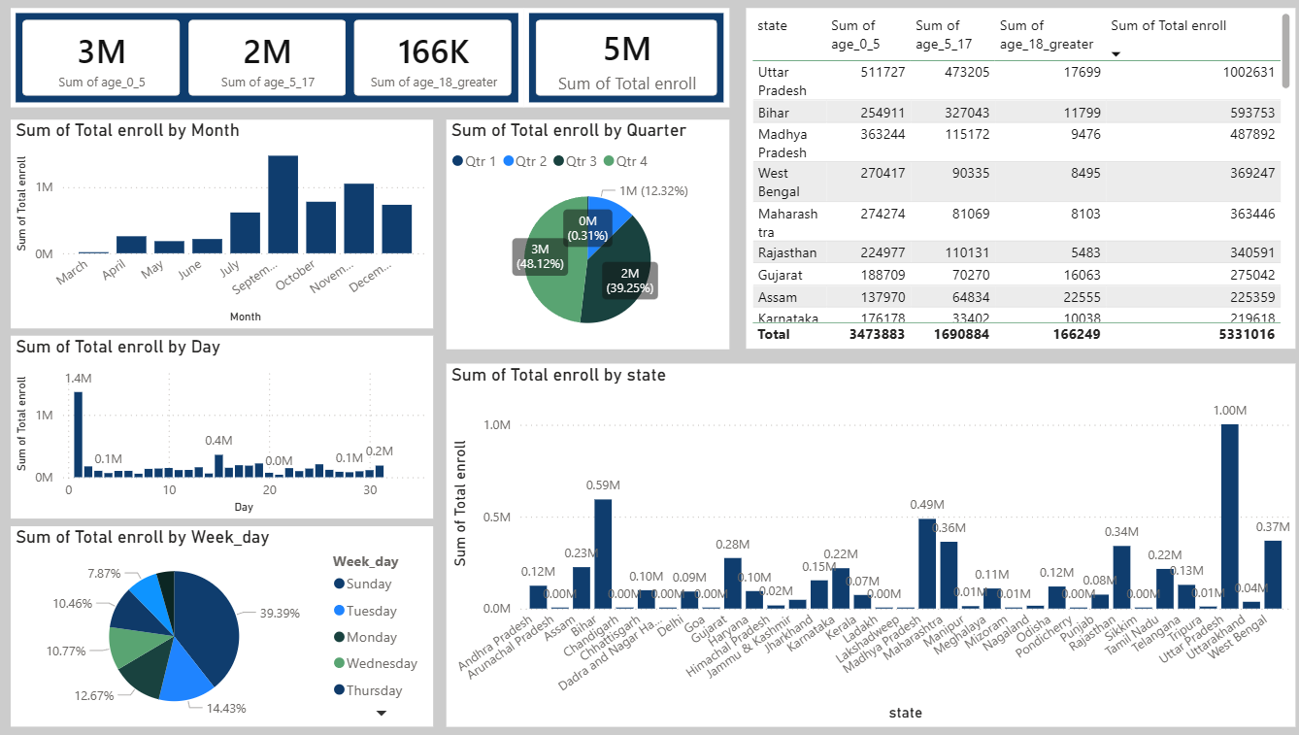
5.1 Enroll Data Analysis:

5.1.1 Overall Enrolment Distribution
The total enrolment captured in the dataset is approximately 5.3 million. A significant proportion of enrolments belongs to the 0–17 years age group, while enrolment in the 18 years and above category is comparatively low. This indicates that Aadhaar enrolment activity is currently dominated by child registration and school-age population rather than adult enrolment.
Adult Aadhaar enrolment appears to have reached saturation, or adult-focused enrolment and update initiatives are limited in comparison to child-centric processes.

5.1.2 Temporal (Time-Based) Patterns
Enrolment activity is highly seasonal. The majority of enrolments are concentrated in the second half of the year, with a clear peak during September, followed by October, November, and December. In contrast, enrolment activity in the early months of the year is minimal or absent in the dataset.
Quarter-wise analysis shows that Quarter 3 and Quarter 4 together account for the vast majority of total enrolments, while Quarter 1 and Quarter 2 contribute only a small fraction.
Aadhaar enrolment is not evenly distributed throughout the year and is strongly influenced by seasonal or program-driven factors.

5.1.3 Data Availability and Reporting Gaps
Certain months (notably January, February, and August) show zero or near-zero enrolment across all datasets. Since this absence is consistent across multiple datasets, it indicates data unavailability or reporting gaps, rather than a complete halt in enrolment activity.
Zero values in these months reflect missing or unpublished data, not actual operational inactivity.

5.1.4 Day-wise and Weekday-wise Behaviour
Day-wise and weekday-wise analysis reveals unusually high enrolment on specific days, such as the first day of the month and Sundays, particularly in the early part of the year. This pattern is not operationally realistic, as enrolment centres typically do not function uniformly on these days.
In contrast, enrolment in the later months of the year is more evenly distributed across weekdays. The dataset reflects reporting behavior (batch or delayed uploads) more strongly than real-time operational activity, especially in the initial months.

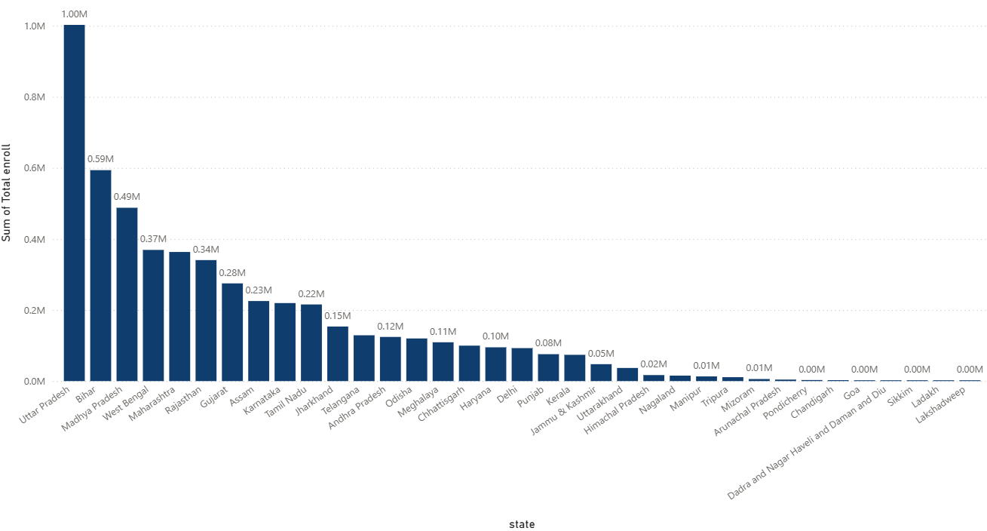
5.1.5 State-wise Enrolment Patterns

State-wise analysis shows that enrolment volumes closely follow population distribution. High-population states such as Uttar Pradesh, Bihar, Madhya Pradesh, West Bengal, and Maharashtra contribute the highest enrolment numbers.
Across states, the age-wise and seasonal patterns remain consistent, with child enrolment dominating and peaks occurring in the same months.
Differences across states are primarily in magnitude (volume) rather than behavior (pattern), indicating a centrally driven enrolment process rather than state-specific variation.

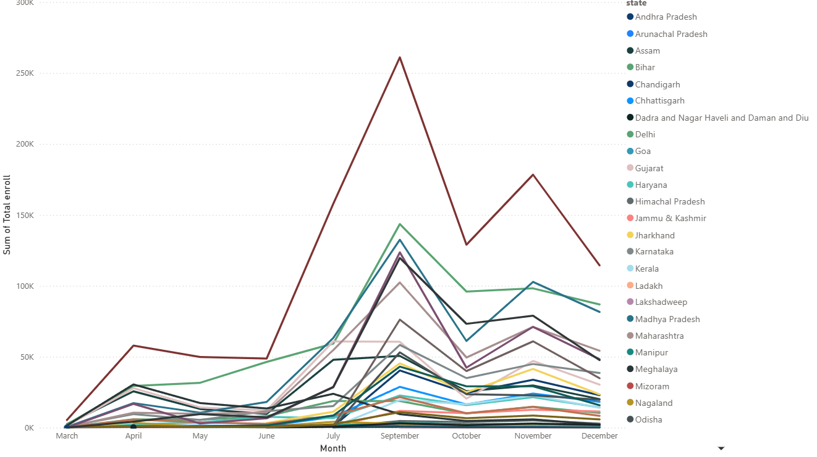
5.1.6 Similarity of Trends Across States

Monthly trend analysis reveals that states can be grouped into high, medium, and low enrolment clusters based on volume. However, all clusters follow a similar seasonal trajectory, characterized by a sharp rise in the mid-year, a peak in September, and a gradual decline thereafter.
Aadhaar enrolment behavior is nationally synchronized, suggesting uniform policy influence and centrally coordinated enrolment drives.
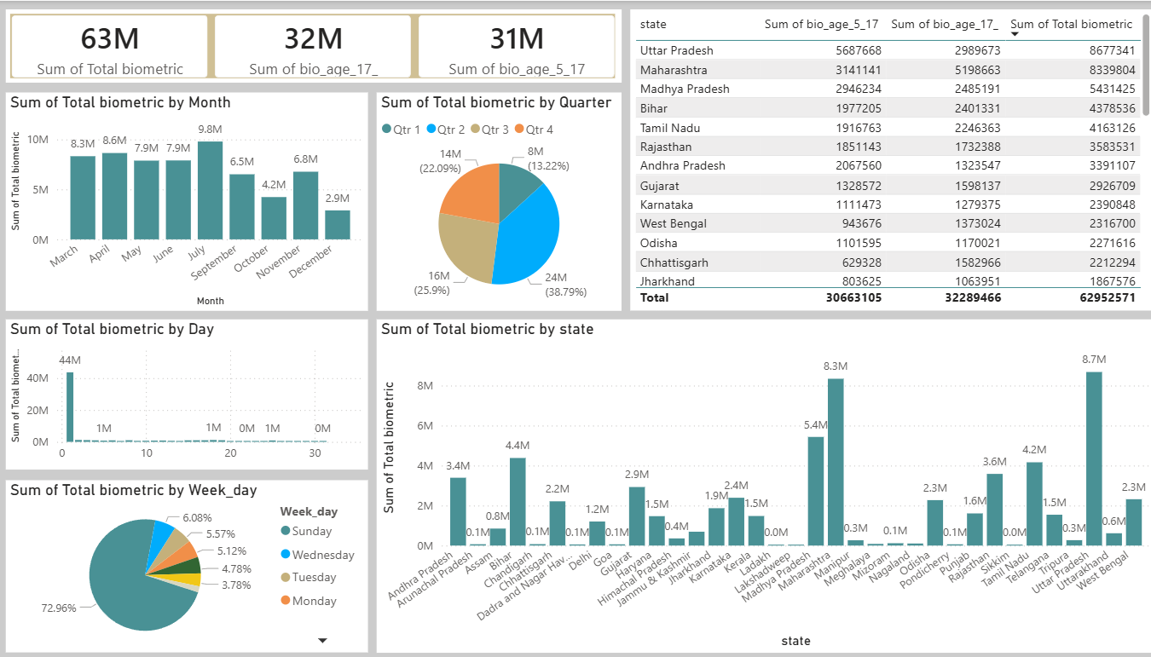
5.2 Biometric Data Analysis

5.2.1 Overall Biometric Activity Distribution
The dataset records approximately 63 million biometric transactions. The contribution from the 5–17 years and 17+ years age groups is almost equal, indicating balanced biometric activity across age categories.
Biometric activity represents a continuous Aadhaar lifecycle process rather than a one-time enrolment-driven activity.

5.2.2 Age-wise Biometric Distribution

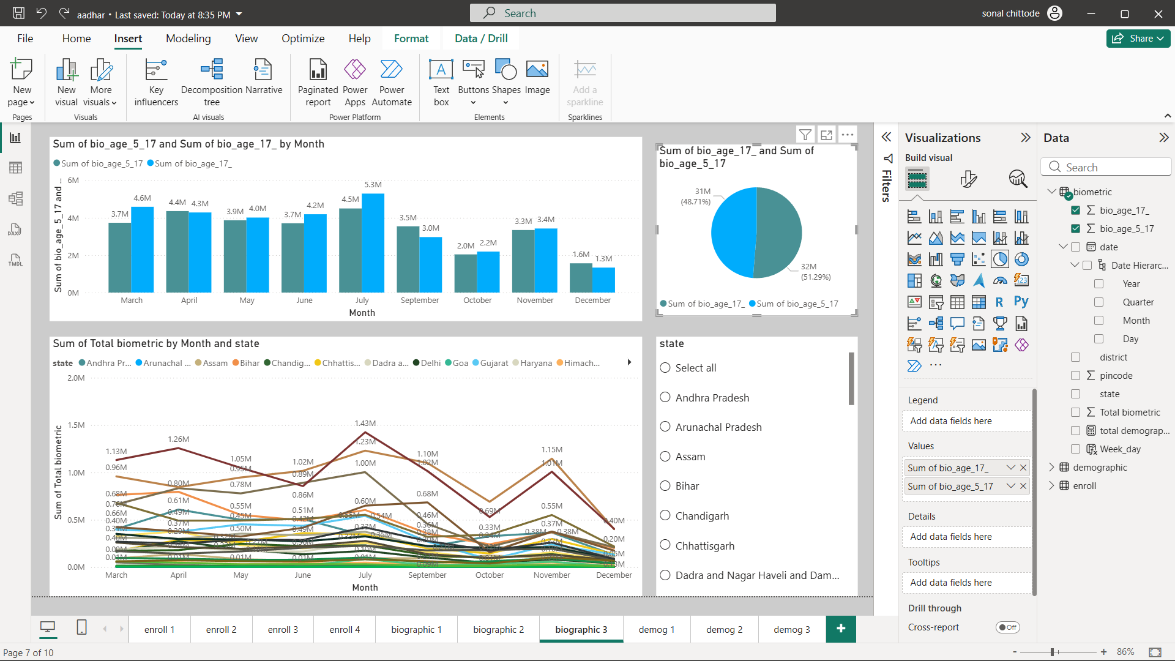
Across all months, biometric updates are almost evenly distributed between children and adults. No month shows extreme dominance of a single age group.
Unlike enrolment data, biometric updates are not age-concentrated and reflect long-term maintenance of Aadhaar records.

5.2.3 Temporal (Month-wise) Patterns
Month-wise analysis reveals a common national pattern across states. Biometric activity increases gradually in the mid-year period, peaks around July, declines during September–October, shows a secondary rise in November, and drops sharply in December.
Biometric activity follows a nationally synchronized operational cycle rather than state-specific seasonal behavior.

5.2.4 Quarter-wise Distribution
Quarter-wise analysis indicates that biometric activity is relatively evenly distributed across quarters, with slight dominance in the middle quarters of the year.
This confirms the continuous nature of biometric updates, in contrast to the strong seasonality observed in enrolment data.

5.2.5 Day-wise Activity Pattern
Day-wise distribution shows extremely high biometric counts recorded on limited specific days, while most days show negligible activity.
This pattern is operationally unrealistic and suggests batch-wise or delayed reporting rather than actual daily biometric capture.

5.2.6 Weekday-wise Behaviour
Weekday-wise analysis indicates disproportionately high biometric activity recorded on Sundays, with significantly lower counts on other weekdays.
The dataset reflects reporting behavior more strongly than real-time service delivery patterns.

5.2.7 State-wise Biometric Distribution

State-wise analysis shows that biometric volumes closely align with population size and Aadhaar base strength. High-population states consistently record higher biometric activity, while smaller states and Union Territories record lower volumes.
State-wise differences are driven by volume (scale), not by behavioral variation.

5.2.8 Similarity of Trends Across States

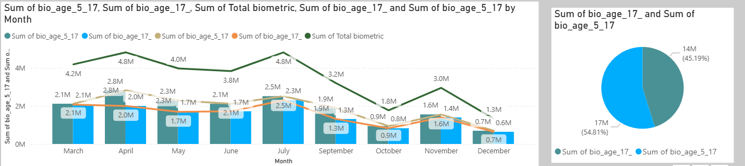
The states Uttar Pradesh, Maharashtra, Bihar, Rajasthan, Madhya Pradesh, Kerala, Andhra Pradesh, Delhi, Chhattisgarh, and Jharkhand exhibit a highly similar month-wise biometric trend pattern. Also in this months high biometric records captured .
In these states, biometric activity shows:
- A sharp increase during April, July, and November
- A sudden decline during October and December
- Relatively stable and comparable biometric levels during May, June, and September
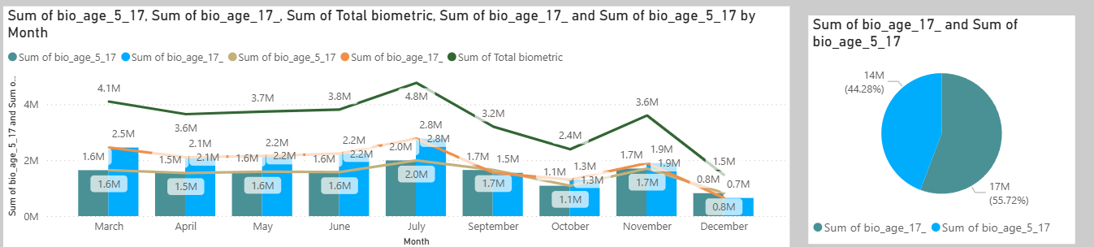
The remaining states (as observed in the second visualization) do not strictly follow the above pattern. Their biometric activity shows:
- Compare to previous one trend there are in march month have many many biometric records then April and mostly state follow this trends
- stable and comparable biometric levels during May, June, and September

States with Higher Biometric Activity in Age 5–17
(High → Low total biometric volume)
- Uttar Pradesh
- Andhra Pradesh
- Telangana
- Chandigarh
- Mizoram
- Assam
These states show stronger biometric participation from children and adolescents, possibly influenced by school-linked or age-mandated biometric update requirements.

States with Higher Biometric Activity in Age 17+
The following states show maximum biometric contribution from the 17+ age group:
- Arunachal Pradesh
- Bihar
- Chhattisgarh
- Kerala
- Maharashtra
- Meghalaya
- Nagaland
- Puducherry
- Punjab
- West Bengal
- Delhi
- Haryana
- Jharkhand

States with Balanced Biometric Contribution Across Age Groups
In the remaining states, biometric activity from age_5–17 and age_17+ groups is almost equal, indicating:
- No clear age dominance
- Continuous biometric engagement across the population
These states represent a balanced biometric lifecycle, where updates are evenly distributed across age groups.

5.3 Demographic Data Analysis
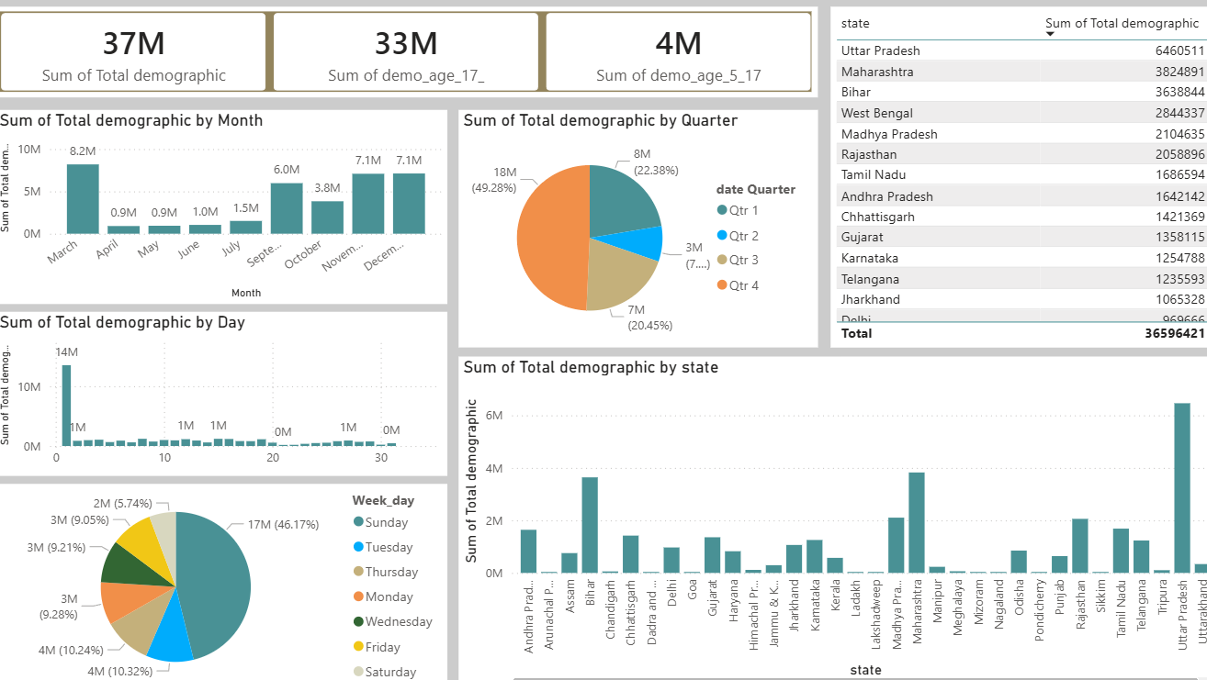

5.3.1 Overall Demographic Update Volume
The dataset records approximately 37 million demographic update transactions. Of these, around 33 million transactions belong to the 17+ age group, while approximately 4 million transactions belong to the 5–17 age group.
Demographic updates are overwhelmingly adult-driven, reflecting address changes, personal detail corrections, and lifecycle-related updates among the working and migrating population.

5.3.2 Age-wise Demographic Distribution
The dominance of the 17+ age group is consistent across almost all states. The contribution of the 5–17 age group is comparatively small and remains secondary throughout the dataset.
Unlike biometric updates (which are balanced across age groups), demographic updates are primarily associated with adult mobility, employment, and residence changes.

5.3.3 Month-wise Temporal Pattern
Month-wise analysis reveals a clear increase in demographic updates toward the end of the year. Activity remains relatively lower during early and mid-year months, followed by sharp increases during September, November, and December.
This end-year concentration is observed consistently across states.
Demographic updates are influenced by administrative cycles, address verification requirements, and year-end documentation needs.

5.3.4 Quarter-wise Distribution
Quarter-wise analysis shows that Quarter 4 contributes nearly half of total demographic updates, followed by Quarter 3. Quarters 1 and 2 together account for a relatively smaller share.
Demographic update activity is strongly concentrated in the second half of the year, even more than enrolment and biometric datasets.

5.3.5 Day-wise Activity Concentration
Day-wise analysis shows extremely high demographic update counts recorded on specific days, while most other days register very low activity.
This pattern is operationally implausible and clearly indicates batch-wise or delayed data uploads, rather than actual same-day demographic update activity.

5.3.6 Weekday-wise Behaviour
Weekday-wise analysis shows a disproportionately high share of demographic updates recorded on Sundays, with comparatively uniform distribution across other weekdays.
As Aadhaar service centres do not typically operate at scale on Sundays, this confirms that weekday-level patterns largely reflect reporting behavior instead of operational reality.

5.3.7 State-wise Demographic Distribution
State-wise analysis indicates that demographic update volumes closely align with population size and migration intensity. High-population states such as Uttar Pradesh, Maharashtra, Bihar, West Bengal, and Madhya Pradesh contribute the largest share of demographic updates.
Smaller states and Union Territories show significantly lower volumes.
State-wise differences are driven primarily by population scale and mobility, not by differences in demographic update behavior.

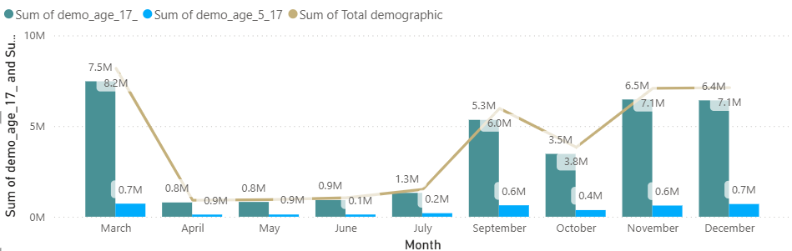
State-wise Monthly Trend Grouping
State-wise month-level analysis of the demographic dataset indicates that demographic update activity does not follow a uniform pattern across all states. Based on similarities in month-wise rise and fall behavior, states can be classified into the following major trend groups.

Group 1: End-of-Year Surge States (Strong Q4 Dominance)
States: Uttar Pradesh, Maharashtra, Bihar, Madhya Pradesh, Rajasthan, West Bengal
- Very low demographic update activity during March–June
- Sharp increase beginning in September
- Peak activity during November–December
- December represents the annual maximum for several states In these states, demographic updates are largely driven by year-end administrative processes, migration-related address changes, and documentation cycles. These states contribute the largest share of demographic updates and strongly influence the national-level trend.

Group 2: Dual-Peak States (September and November Peaks)

States: Delhi, Gujarat, Karnataka, Tamil Nadu, Haryana, Punjab, Kerala
- Gradual rise after July
- First peak in September
- Slight decline in October
- Second peak in November
- Mild decline or stabilization in December
These states show continuous but structured demographic update activity, likely influenced by sustained urban mobility and employment-related demographic changes. They represent states with relatively stable and evenly distributed demographic processing.

Group 3: Low-Volume but Nationally Synchronized States
States: Chhattisgarh, Jharkhand, Assam, Odisha, Himachal Pradesh, Uttarakhand, Jammu & Kashmir
- Overall lower demographic update volumes
- Clear peaks within the September–November window
- Minimal activity during the rest of the year
Despite lower volumes, these states follow the same national demographic update cycle, confirming that timing is centrally driven while scale is state-dependent.

Group 4: Irregular or Reporting-driven Pattern States
States: Arunachal Pradesh, Manipur, Mizoram, Meghalaya, Nagaland, Tripura, Sikkim, Ladakh, Lakshadweep
- Sudden spikes in isolated months (e.g., March or November)
- Near-zero activity in most other months
- Lack of smooth or continuous trends
Demographic update data in these states is likely influenced by batch reporting or delayed uploads, rather than steady operational activity.
Such states should be interpreted with caution in trend-based analysis.

Overall Relationship and Trend Analysis Across All Three Aadhaar Datasets
This section consolidates insights from the Aadhaar Enrolment, Biometric, and Demographic datasets to identify common patterns, key differences, and their implications for system behavior and policy planning.

1. Lifecycle Relationship Across Datasets
- Enrolment reflects the onboarding phase, primarily driven by first-time registrations.
- Biometric reflects the maintenance phase, involving periodic biometric updates across age groups.
- Demographic reflects the information update phase, largely driven by adult lifecycle events such as migration, employment, and address changes.
Together, the datasets illustrate a complete Aadhaar lifecycle—from creation to continuous maintenance and periodic information updates.

2. Common Temporal Synchronization
Despite representing different processes, all three datasets exhibit nationally synchronized timing patterns:
- Activity is concentrated in the second half of the year across all datasets.
- Peaks occur in overlapping windows (especially September–November).
- Early-year months show consistently lower activity or data unavailability.
Timing of Aadhaar-related activities is centrally driven, not state-specific.

3. Differing Seasonal Intensity
While synchronized in timing, the degree of seasonality differs:
- Enrolment: Highly seasonal and campaign-driven, with sharp peaks and long inactive periods.
- Biometric: Moderately seasonal but relatively continuous throughout the year.
- Demographic: Strongly end-year concentrated, with pronounced Q4 dominance.
Main Point:
Each dataset responds differently to centralized schedules based on its operational nature.

4. Age-group Dependency Contrast
Age-wise behavior differs sharply across datasets:
- Enrolment: Dominated by the 0–17 years age group.
- Biometric: Balanced participation from 5–17 and 17+ age groups.
- Demographic: Heavily dominated by the 17+ age group.
Age dominance shifts logically across lifecycle stages, validating the internal consistency of the datasets.

5. State-wise Scale vs Behavior Consistency
Across all three datasets:
- State-wise volume rankings closely follow population size.
- High-population states consistently dominate across months and datasets.
- Trend shapes (rise and fall patterns) remain similar across states, regardless of volume.
State-level differences are driven by scale, not by behavioral variation.

6. Reporting-driven Temporal Distortions
All three datasets show:
- Unusually high activity on specific days.
- Disproportionately large shares recorded on Sundays.
These patterns are operationally unrealistic.
Fine-grained temporal patterns reflect reporting and upload behavior, not actual daily service delivery.

KEY INSIGHTS AND FINDINGS
The analysis indicates that Aadhaar operates as a lifecycle-oriented identity system rather than a one-time registration mechanism. Enrolment marks the point of entry into the system, while biometric and demographic updates reflect its continuous use and maintenance over time. Together, these activities demonstrate that Aadhaar records evolve in response to changes in age, physical attributes, and personal circumstances, highlighting the dynamic nature of the system.
A consistent national-level pattern is observed across Aadhaar-related activities. Enrolment, biometric updates, and demographic updates all show increased activity during the second half of the year, particularly between September and November. This uniform timing across states suggests that Aadhaar operations are largely influenced by centrally coordinated administrative schedules rather than independent state-level factors. Although the timing of activity is similar, the intensity varies by type of activity. Enrolment shows strong seasonal concentration, biometric updates are more evenly distributed throughout the year, and demographic updates are heavily concentrated toward the end of the year.
Distinct age-related trends further support the functional differences within Aadhaar operations. Enrolment activity is predominantly associated with children and adolescents, biometric updates involve both younger and older age groups in nearly equal proportion, and demographic updates are primarily driven by adults. These patterns align with practical realities, as enrolment typically occurs early in life, biometric information requires periodic updates across all ages, and demographic details are more frequently updated by adults due to migration, employment changes, and address modifications.
State-level analysis reveals that Aadhaar activity volumes are closely aligned with population size and Aadhaar base coverage. States with larger populations consistently record higher levels of activity, while smaller states and Union Territories contribute lower volumes. However, despite differences in scale, the overall trend patterns remain similar across states. This indicates that variations are driven more by population size than by differences in implementation or behaviour, reflecting uniform execution of Aadhaar processes nationwide.
The analysis also highlights limitations related to reporting practices. Day-wise and weekday-wise patterns show unusually high activity on specific days and disproportionately large volumes recorded on Sundays. Such patterns are inconsistent with normal operational functioning and suggest the presence of batch or delayed data uploads. As a result, while monthly and quarterly trends provide meaningful insights, interpretations based on finer temporal granularity should be made with caution.
Overall, viewing enrolment, biometric, and demographic activities together provides a comprehensive understanding of Aadhaar system behaviour. An integrated approach is essential to accurately capture how Aadhaar is adopted, maintained, and updated across different regions and population groups.

IMPACT AND APPLICABILITY
The findings of this analysis have significant practical and policy-level implications for the planning, management, and evaluation of Aadhaar-related operations. By highlighting clear temporal, demographic, and geographic patterns, the study provides a deeper understanding of how Aadhaar services are actually used across different stages of the identity lifecycle. This understanding can support more informed decision-making by administrators and policymakers responsible for managing Aadhaar infrastructure and related services.
The identification of strong national-level synchronisation in Aadhaar activities enables better operational planning and resource allocation. Since enrolment, biometric updates, and demographic updates tend to peak during similar periods, especially in the second half of the year, authorities can proactively allocate staff, enrolment centres, and technical resources to high-demand periods. This can help reduce service bottlenecks, waiting times, and system overload during peak months while improving utilisation during low-activity periods.
State-wise analysis showing that activity levels are primarily driven by population size rather than behavioural differences has important applicability for capacity planning. High-population states require proportionally greater infrastructure and operational support, whereas smaller states may benefit more from targeted interventions rather than large-scale expansion. This insight supports equitable and data-driven distribution of resources across regions.
The age-group patterns observed in Aadhaar activities also have direct policy relevance. Child-dominated enrolment trends highlight the continued importance of early-life identity inclusion, while balanced biometric activity across age groups reflects the need for sustained biometric maintenance throughout the lifecycle. Adult-dominated demographic updates underscore the impact of migration, employment, and urbanisation on identity information. These insights can inform the design of targeted awareness campaigns, update drives, and citizen outreach programs tailored to specific age groups.
Additionally, the identification of reporting-related distortions at finer temporal levels has important implications for data interpretation and governance. Recognising that day-wise and weekday-wise patterns may reflect reporting behaviour rather than real-time service delivery helps prevent misinformed conclusions and supports more accurate performance evaluation. This insight can guide improvements in reporting transparency, data quality standards, and monitoring frameworks.
The integrated insights from this analysis enhance the applicability of Aadhaar data for strategic planning, operational optimisation, and policy formulation. By viewing Aadhaar as a dynamic, lifecycle-based system rather than a static identification mechanism, stakeholders can better align administrative processes with real-world usage patterns, ultimately improving service delivery and governance effectiveness.

SUGGESTIONS
Based on the insights derived from the analysis, several actionable suggestions can be proposed to strengthen Aadhaar operations and improve governance outcomes. These suggestions focus on operational efficiency, data quality, inclusiveness, and long-term system improvement.
First, Aadhaar operations can be improved through better demand-based capacity planning. Since activity levels peak during specific periods of the year, especially in the second half, staffing, enrolment centres, and technical infrastructure should be scaled proactively during high-demand months. During low-activity periods, resources can be redirected toward staff training, system upgrades, and outreach programs to ensure balanced utilisation throughout the year.
Second, targeted enrolment and update initiatives should be designed based on age-group behaviour. Child-dominated enrolment patterns suggest stronger integration with birth registration systems, schools, and child welfare programs. Adult-dominated demographic updates indicate the need for focused awareness campaigns in urban, industrial, and high-migration areas to encourage timely updates of address and personal details.
Third, the government should strengthen data reporting and monitoring mechanisms. The presence of reporting-related distortions at day-wise and weekday-wise levels highlights the need to clearly distinguish between service delivery dates and data upload dates. Improving reporting transparency and encouraging near real-time data submission would enhance the reliability of monitoring and performance evaluation.
Fourth, state-level planning should be aligned with population scale and service demand. High-population states require sustained infrastructure and workforce support, while smaller states and Union Territories may benefit more from mobile enrolment units and periodic update drives. Such an approach ensures equitable and efficient allocation of public resources.
Fifth, the adoption of normalized and per-capita indicators is recommended to complement absolute activity counts. Normalized metrics can provide a clearer picture of service reach and efficiency across states, helping policymakers identify under-served regions and design targeted interventions.
Finally, greater integration across Aadhaar-related activities should be encouraged. Analysing enrolment, biometric updates, and demographic updates together enables a lifecycle-based understanding of Aadhaar usage and supports more informed decision-making. This integrated approach can strengthen Aadhaar’s role as a foundational digital identity supporting inclusive and efficient public service delivery.

CONCLUSION
This analysis provides a comprehensive understanding of how Aadhaar functions as a dynamic and lifecycle-driven identity system in India. By examining enrolment, biometric updates, and demographic updates together, the study reveals how Aadhaar is created, maintained, and continuously updated in response to changing individual and administrative needs. Rather than being a one-time registration process, Aadhaar emerges as an evolving system that supports long-term governance and service delivery.
The findings highlight strong national-level synchronisation in Aadhaar activities, with demand concentrated during specific periods of the year. While enrolment activity is largely seasonal and child-dominated, biometric updates occur continuously across age groups, and demographic updates are primarily driven by adults, particularly toward the end of the year. Across states, variations in activity are mainly influenced by population size rather than behavioural differences, reflecting uniform implementation of Aadhaar processes across the country.
At the same time, the analysis identifies important limitations related to reporting practices, especially at finer temporal levels. Observed anomalies in day-wise and weekday-wise patterns indicate that some trends reflect reporting behaviour rather than actual service delivery. Recognising these limitations is essential for accurate interpretation and effective monitoring of Aadhaar operations.The study demonstrates the value of an integrated, data-driven approach to understanding Aadhaar. The insights generated can support better capacity planning, targeted enrolment and update initiatives, improved reporting transparency, and more informed policy decisions. By aligning Aadhaar operations with real usage patterns and lifecycle needs, the system can be further strengthened to enhance efficiency, inclusiveness, and trust in public service delivery.

Source Code Repository
The complete source code and Jupyter notebooks used for this analysis are publicly available on GitHub at the following link:
Sonalchittode/aadhaar-analytics-project: Aadhaar Enrollment, Demographic and Biometric Analysis
The repository contains all executable notebooks, datasets, and instructions required to reproduce the analysis.

